**LAB 4: Heuristic Evaluation of a Mobile Application**

**1. Enter Your Name and Register Number:**

|  |
| --- |
| **Shalu Kumari (1947259)** |

**2. Enter the Domain Chosen:**

|  |
| --- |
| **Social Media** |

**3. Enter the Application Chosen:**

|  |
| --- |
| **Whatsapp** |

**1. Visibility of System Status:   
Heuristic Violated: No**

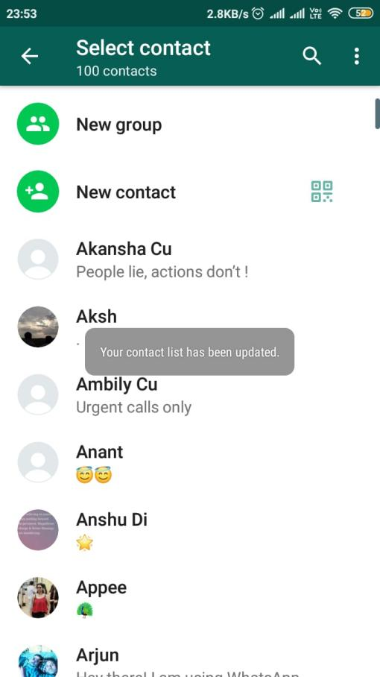

**Explanation**:

|  |
| --- |
| As it gives the information related to the action performed by the user. |

**2. Match between System and Real World:   
Heuristic Violated:**

**Explanation**:

|  |
| --- |
| In whatsapp, now they added a new feature, I.e. you can pay the bill via Whatsapp, and these are related to system not the real world . So, it doesn’t follow the real world conventions. |

**3. User Control and Freedom  
Heuristic Violated: No**



**Explanation**:

|  |
| --- |
| If user has send any kind of media like images, videos, etc. To someone mistakenly, he/she can delete at any time. The user has the freedom to remove it within 7 minutes, even after receiver watched that message. |

**4. Consistency and Standards  
Heuristic Violated: No**

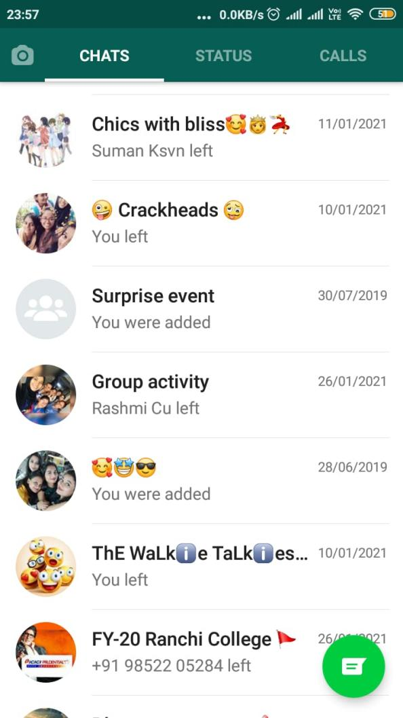

**Explanation**:

|  |
| --- |
| Whatsapp maintains consistency by placing the above bar with search button on top, chats, status, calls, hamburger menu on the top right corner and it makes convenient to the users and doesn’t makes them think much. |

**5. Error Prevention  
Heuristic Violated: No**

**Explanation**:

|  |
| --- |
| When the person is using whatsapp and he wants to record his voice first time, it will asks for the permission to record audio before they perform the action |

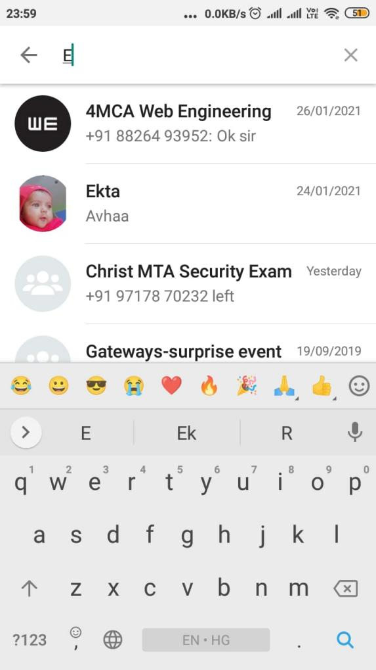**6. Recognition rather than recall  
Heuristic Violated: No**

**Explanation**:

|  |
| --- |
| While searching some person in your whatsapp contacts, if you type the first letter of that person name, it will show all those contacts who has that letter, even you can search like that in chats. |

**7. Flexibility and efficiency of use**  
**Heuristic Violated:**

**Explanation**:

|  |
| --- |
|  |

**8. Aesthetic and minimalist design**  
**Heuristic Violated:**

**Explanation**:

|  |
| --- |
|  |

**9. Help users recognize, diagnose, and recover from errors**

**Heuristic Violated:**

**Explanation**:

|  |
| --- |
|  |

**10. Help and documentation**

**Heuristic Violated: No**

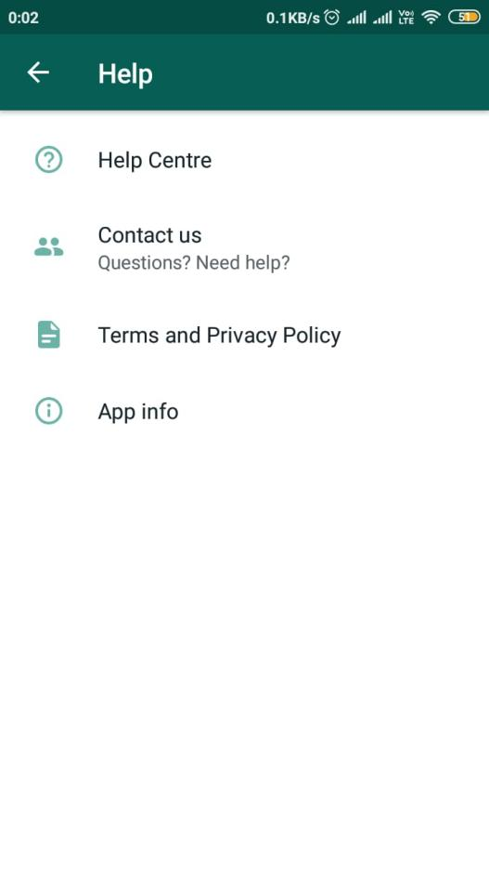

**Explanation**:

|  |
| --- |
| Whatsapp has help center that provides the help/support to the users with the option message/call. Even, it has some documented app info, terms and privacy policies. |

**\*\*\*\*\*\*\*\*\*\*\*\*\*\***